**OOPS ASSIGNMENT**

1.)Person.java

import java.util.Scanner;  
public class Person {  
 private String name;  
 private int age;  
 public Person(String name, int age) {  
 this.name = name;  
 this.age = age;  
 }  
 public String getName() {  
 return name;  
 }  
 public int getAge() {  
 return age;  
 }  
}

Main.java

public class Main {  
 public static void main(String[] args) {  
 Person p1 = new Person("Anitta George", 22);  
 Person p2 = new Person("Annmary Shybu", 21);  
 System.*out*.println("Name : "+ p1.getName() + "Age : "+ p1.getAge());  
 System.*out*.println("Name : "+p2.getName() + "Age : " + p2.getAge());  
  
  
 }  
}

Output:

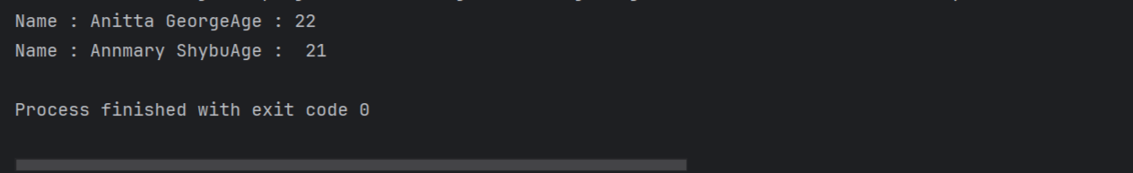

2.)Dog.java

public class Dog {  
 private String name;  
 private String breed;  
  
 public Dog(String name, String breed) {  
 this.name = name;  
 this.breed = breed;  
 }  
  
 public String getName() {  
 return name;  
 }  
  
 public void setName(String name) {  
 this.name = name;  
 }  
  
 public String getBreed() {  
 return breed;  
 }  
  
 public void setBreed(String breed) {  
 this.breed = breed;  
 }  
  
}

Main.java

public class Main {  
 public static void main(String[] args) {  
 Dog d1 = new Dog("Blackie", "Pomerenian");  
 Dog d2 = new Dog("Bowie", "Great Pyrenes");  
  
 System.*out*.println("Name of dog : " +d1.getName() + "Breed : " + d1.getBreed());  
 System.*out*.println(d2.getName() + "Breed : " + d2.getBreed());  
  
 System.*out*.println(" New Breed for dog_no_1 and new name for dog_no_2 is :");  
 d1.setBreed("Golden Retriever");  
 d2.setName("Dandy");  
  
 System.*out*.println("Name od dog_no_1 : "+d1.getName() + "Breed : " + d1.getBreed());  
 System.*out*.println("Name of dog_no_2 : "+d2.getName() + "Breed : " + d2.getBreed());  
 }  
}

Output:

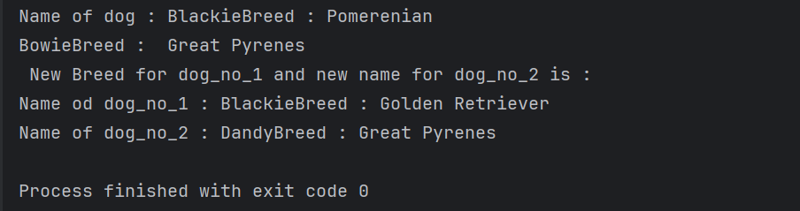

3.)Rectangle.java

public class Rectangle {  
 private double width;  
 private double height;  
  
 public Rectangle(double width, double height) {  
 this.width = width;  
 this.height = height;  
 }  
 public double getWidth() {  
 return width;  
 }  
 public void setWidth(double width) {  
 this.width = width;  
 }  
 public double getHeight() {  
 return height;  
 }  
 public void setHeight(double height) {  
 this.height = height;  
 }  
 public double getArea() {  
 return width * height;  
 }  
 public double getPerimeter() {  
 return 2 * (width + height);  
 }  
}

Main.java

public class Main {  
 public static void main(String[] args) {  
 Rectangle rect = new Rectangle(4, 20);  
  
 System.*out*.println("The area of the rectangle is " + rect.getArea());  
 System.*out*.println("The perimeter of the rectangle is " + rect.getPerimeter());  
  
 rect.setWidth(6);  
 rect.setHeight(22);  
  
 System.*out*.println("The area of the rectangle is now " + rect.getArea());  
 System.*out*.println("The perimeter of the rectangle is now " + rect.getPerimeter());  
 }  
}

Output:

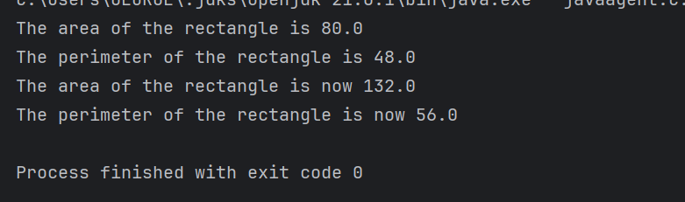

4.)Circle.java

public class Circle {  
 private double r;  
  
 public Circle(double radius) {  
 this.r = radius;  
 }  
  
 public double getRadius() {  
 return r;  
 }  
  
 public void setRadius(double radius) {  
 this.r = radius;  
 }  
  
 public double getArea() {  
 return Math.*PI* * r * r;  
 }  
  
 public double getPerimeter() {  
 return 2 * Math.*PI* * r;  
 }  
}

Main.java

public class Main {  
 public static void main(String[] args) {  
 int r = 3;  
 Circle circle = new Circle(r);  
 System.*out*.println("Radius of circle : " + r);  
 System.*out*.println("Area of circle : " + circle.getArea());  
 System.*out*.println("Perimerter of circle : " + circle.getPerimeter());  
 r = 9;  
 circle.setRadius(r);  
 System.*out*.println("Radius of the circle : " + r);  
 System.*out*.println("The area of the circle : " + circle.getArea());  
 System.*out*.println("The perimeter of the circle : " + circle.getPerimeter());  
 }  
}

Output:

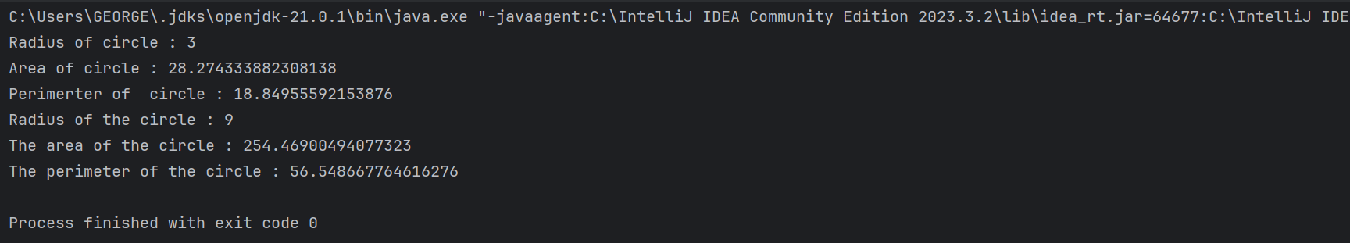

5.)Employee.java

public class Employee {  
 private String name;  
 private String jobTitle;  
 private double salary;  
  
 public Employee(String name, String jobTitle, double salary) {  
 this.name = name;  
 this.jobTitle = jobTitle;  
 this.salary = salary;  
 }  
  
 public String getName() {  
 return name;  
 }  
  
 public void setName(String name) {  
 this.name = name;  
 }  
  
 public String getJobTitle() {  
 return jobTitle;  
 }  
  
 public void setJobTitle(String jobTitle) {  
 this.jobTitle = jobTitle;  
 }  
  
 public double getSalary() {  
 return salary;  
 }  
  
 public void setSalary(double salary) {  
 this.salary = salary;  
 }  
  
 public void raiseSalary(double percentage) {  
 salary = salary + salary * percentage / 100;  
 }  
  
 public void printEmployeeDetails() {  
 System.*out*.println("Name : " + name);  
 System.*out*.println("Job Title : " + jobTitle);  
 System.*out*.println("Salary : " + salary);  
 }  
}

Main.java

public class Main {  
 public static void main(String[] args) {  
  
 Employee e1 = new Employee("Ancy Paul", "Technical Analyst", 50000);  
 Employee e2 = new Employee("Annmary SHybu", "Product Manager", 70000);  
 System.*out*.println("Employee Details :");  
 e1.printEmployeeDetails();  
 e2.printEmployeeDetails();  
 e1.raiseSalary(10);  
 e2.raiseSalary(17);  
 System.*out*.println("After raising salary :");  
 System.*out*.println("10% for 'Ancy Paul':");  
 e1.printEmployeeDetails();  
 System.*out*.println("17% for 'Annmary Shybu':");  
 e2.printEmployeeDetails();  
 }  
}

Output:

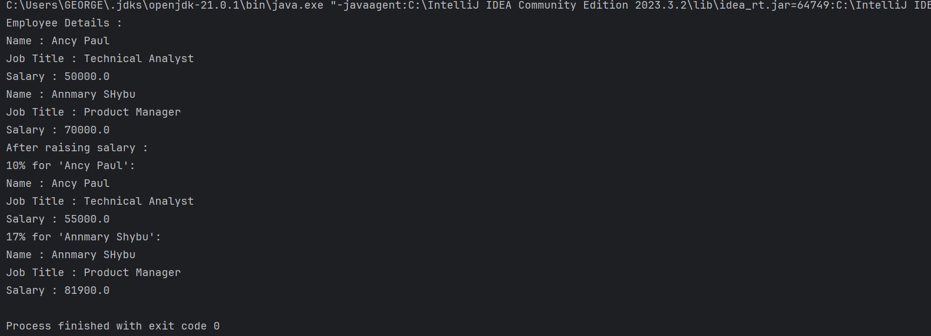

6. ,7.)Bank.java

import java.util.ArrayList;  
  
public class Bank {  
 private ArrayList < Account > accounts;  
  
 public Bank() {  
 accounts = new ArrayList < Account > ();  
 }  
  
 public void addAccount(Account account) {  
 accounts.add(account);  
 }  
  
 public void removeAccount(Account account) {  
 accounts.remove(account);  
 }  
  
 public void depositMoney(Account account, double amount) {  
 account.deposit(amount);  
 }  
  
 public void withdrawMoney(Account account, double amount) {  
 account.withdraw(amount);  
 }  
  
 public ArrayList < Account > getAccounts() {  
 return accounts;  
 }  
  
}

Account.java

public class Account {  
 private String name;  
 private String accountNumber;  
 private double balance;  
  
 public Account(String name, String accountNumber, double balance) {  
 this.name = name;  
 this.accountNumber = accountNumber;  
 this.balance = balance;  
 }  
  
 public String getName() {  
 return name;  
 }  
  
 public void setName(String name) {  
 this.name = name;  
 }  
  
 public String getAccountNumber() {  
 return accountNumber;  
 }  
  
 public void setAccountNumber(String accountNumber) {  
 this.accountNumber = accountNumber;  
 }  
  
 public double getBalance() {  
 return balance;  
 }  
  
 public void setBalance(double balance) {  
 this.balance = balance;  
 }  
  
 public void deposit(double amount) {  
 balance = balance + amount;  
 }  
  
 public void withdraw(double amount) {  
 balance = balance - amount;  
 }  
  
 public String getAccountInfo() {  
 return "Name: " + name + "\n Account Number: " + accountNumber + "\n Balance: " + balance;  
 }  
}

Main.java

import java.util.ArrayList;  
public class Main {  
 public static void main(String[] args) {  
 Bank bank = new Bank();  
  
 Account a1 = new Account("Anitta George", "C0011", 50000);  
 Account a2 = new Account("Ancy Paul", "C0012", 32000);  
 Account a3 = new Account("Annmary Shybu", "C0013", 70000);  
  
 bank.addAccount(a1);  
 bank.addAccount(a2);  
 bank.addAccount(a3);  
  
 ArrayList < Account > as = bank.getAccounts();  
  
 for (Account account: as) {  
 System.*out*.println(account.getAccountInfo());  
 }  
  
 System.*out*.println("After depositing 6000 into account_no_1 :");  
 bank.depositMoney(a1, 6000);  
 System.*out*.println(a1.getAccountInfo());  
 System.*out*.println("No transaction in account_no2 :");  
 System.*out*.println(a2.getAccountInfo());  
 System.*out*.println("After withdrawing 2000 from account_no_3 :");  
 bank.withdrawMoney(a3, 2000);  
 System.*out*.println(a3.getAccountInfo());  
 }  
}

Output:

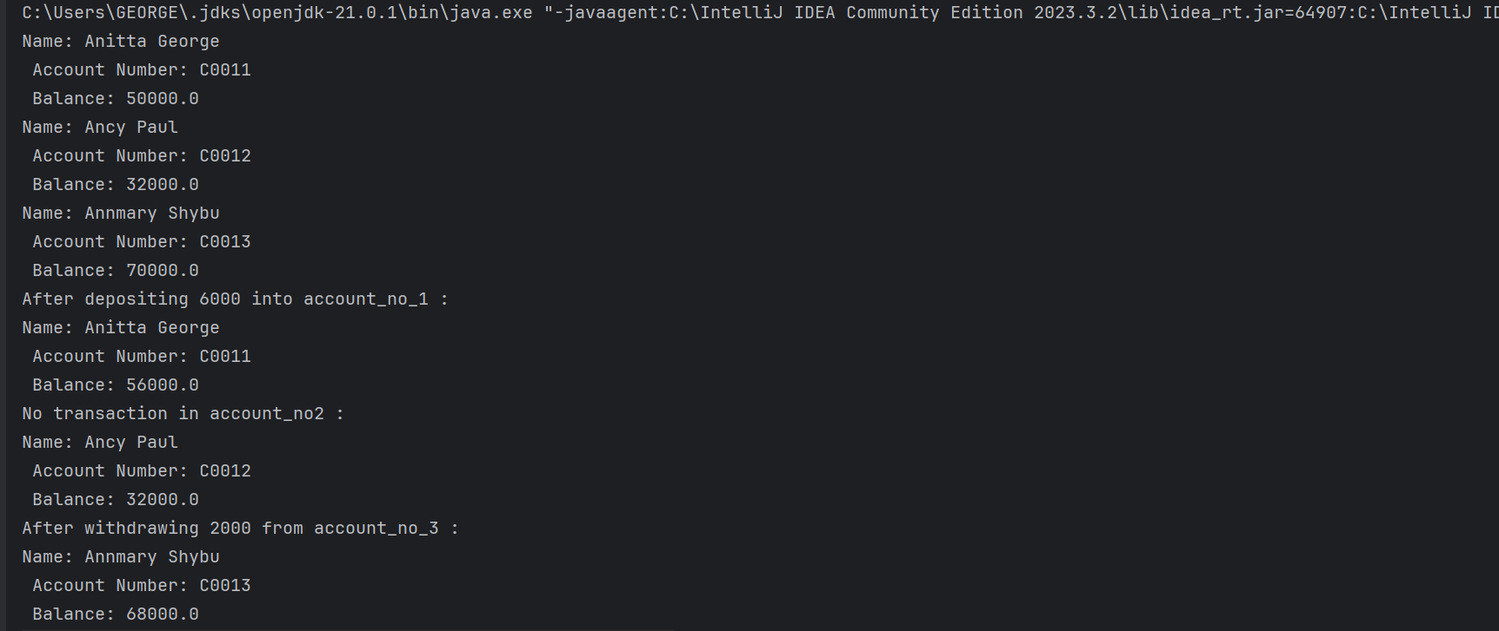

8.)TrafficLight.java

public class TrafficLight {  
 private String color;  
 private int duration;  
  
 public TrafficLight(String color, int duration) {  
 this.color = color;  
 this.duration = duration;  
 }  
  
 public void changeColor(String newColor) {  
 color = newColor;  
 }  
  
 public boolean isRed() {  
 return color.equals("red");  
 }  
  
 public boolean isGreen() {  
 return color.equals("green");  
 }  
  
 public int getDuration() {  
 return duration;  
 }  
  
 public void setDuration(int duration) {  
 this.duration = duration;  
 }  
}

Main.java

public class Main {  
 public static void main(String[] args) {  
 TrafficLight light = new TrafficLight("red", 60);  
 System.*out*.println("Light is red : " + light.isRed());  
 System.*out*.println("Light is green : " + light.isGreen());  
 light.changeColor("green");  
 System.*out*.println("Light now is green : " + light.isGreen());  
 System.*out*.println("Duration of light : " + light.getDuration());  
 light.setDuration(30);  
 System.*out*.println("New duration of light : " + light.getDuration());  
 }  
}

Output:

